1. Assignment Description

This assignment focusses on examining student understanding of Control Flow and Data Flow Graphs. Other topics covered by this section, like Cyclomatic Complexity, DD-Path, ... are also included.

2. Author- Ryan Davis

3. Summary

Results:

1. Control Flow Graph:
   1. 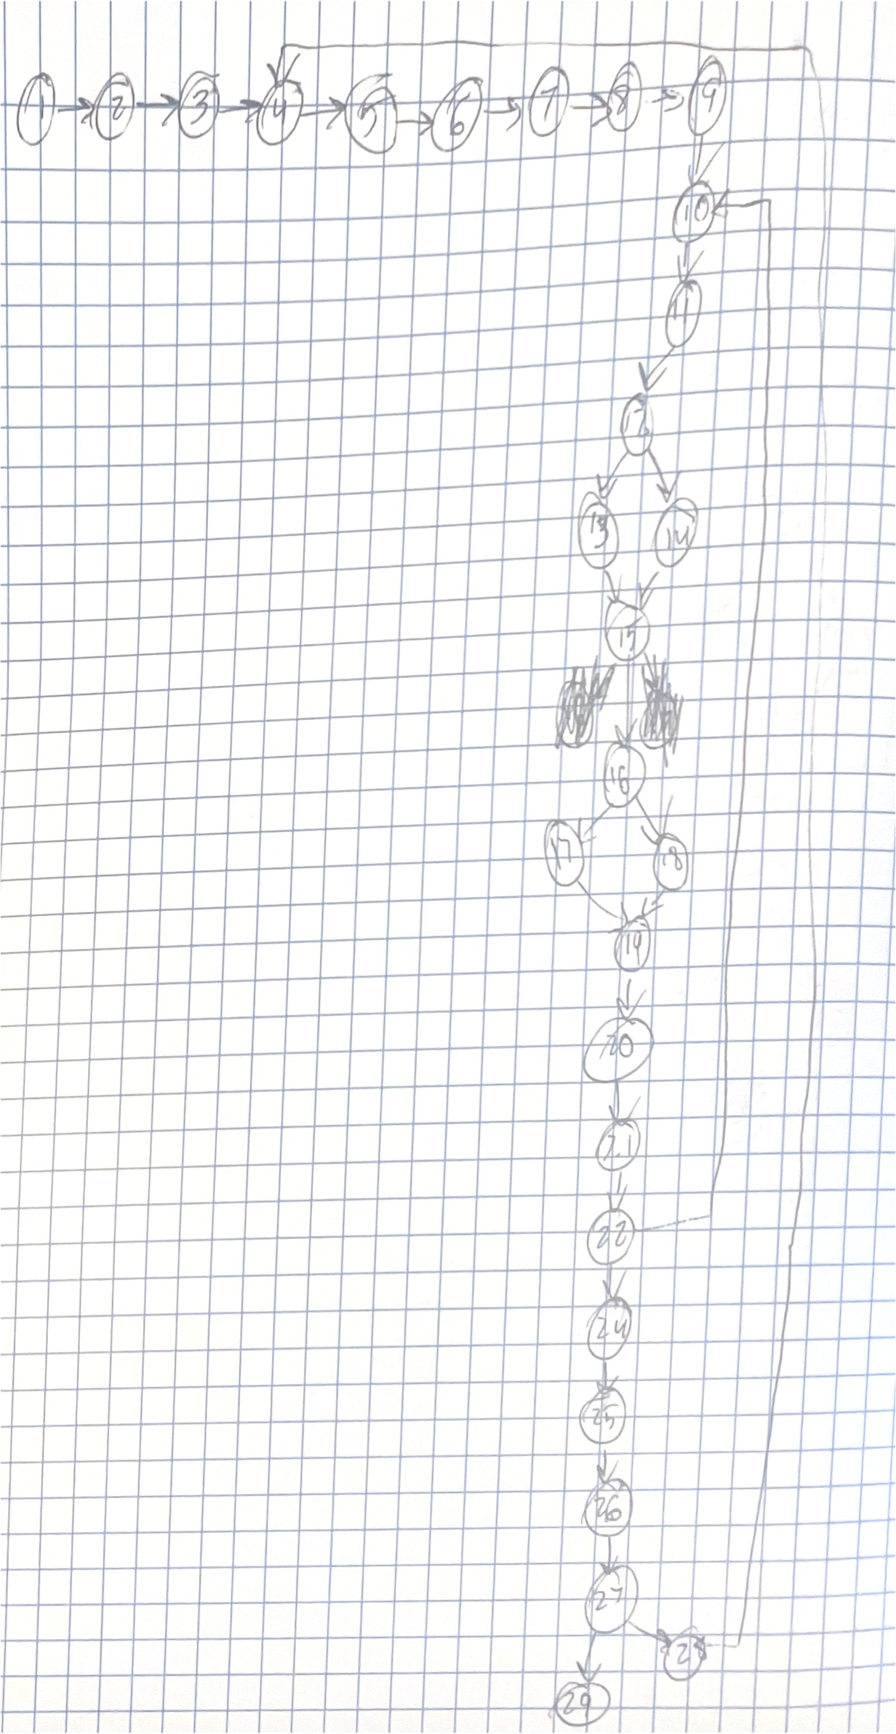
2. Consolidated Graph:

|  |  |
| --- | --- |
| DD-Path Consolidation |  |
| Line # | Node |
| 1-9 | A |
| 10-12 | B |
| 13 | C |
| 14 | D |
| 15-16 | E |
| 17 | F |
| 18 | G |
| 19-27 | H |
| 28 | I |
| 29 | J |

* 1. 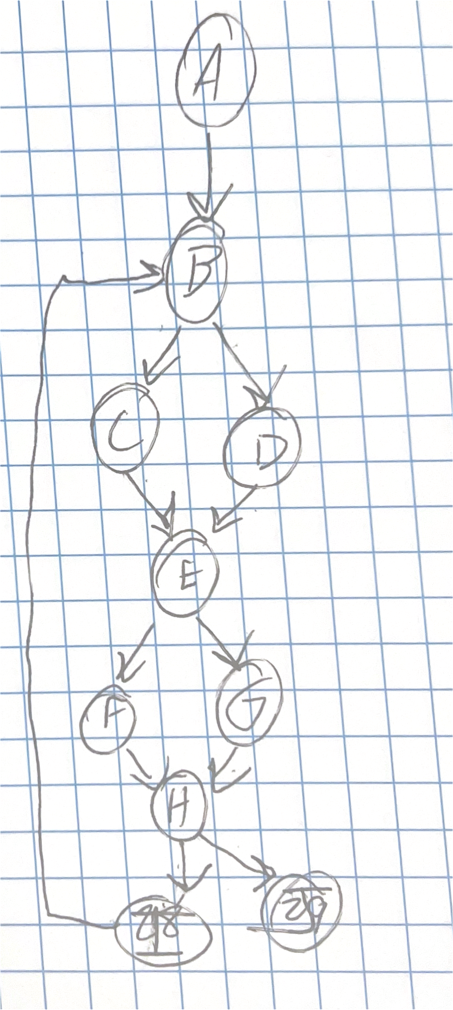

1. Cyclomatic Complexity & Basis Paths:
   1. Cyclomatic Complexity=e-n+2=12-10+2=4

|  |  |
| --- | --- |
| Basis Paths |  |
| 1 | A-B-C-E-F-H-I |
| 2 | A-B-D-E-G-H-J |
| 3 | A-B-C-E-G-H-I-B |
| 4 | A-B-D-E-F-H-J |

Reflection:

* What I learned:
  + How to convert code or pseudocode into a control flow graph, determining the process flow of an algorithm.
  + How to consolidate a control flow graph into a smaller graph by applying decision to decision path methods.
  + Calculating Cyclomatic complexity and using such calculation to create basis paths.
* What worked well:
  + I was able to successfully convert the pseudocode to a control flow graph, which was then consolidated into a simpler graph.
  + I was also able to calculate the cyclomatic complexity and use this for the formation of basis paths.
* Challenges faced:
  + Consolidating nodes on decision nodes and loops is confusing, as there are multiple decision nodes increasing complexity.
  + Creating basis paths that efficiently provides full coverage of the system.

5. Honor Pledge

"I pledge my honor that I have abided by the Stevens Honor System."

Signed: *Ryan Davis*